Analysis of an Employee Dataset
Goal
The goal of this project is to analyse employee data to uncover insights such as Employee demographics (age, gender, city), work experience and leave patterns.

Importing libraries I will use for this project:
Reading and looking at the data:
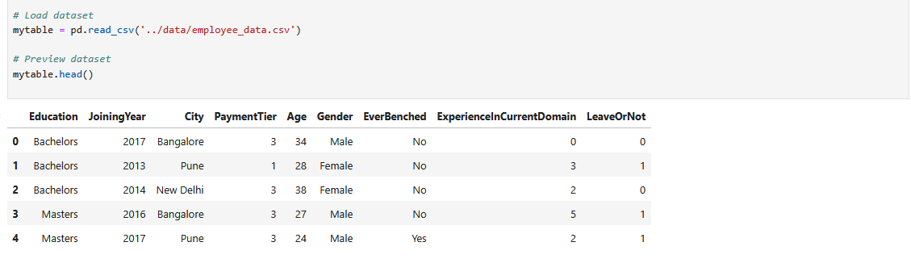
Checking data info and basic statistics
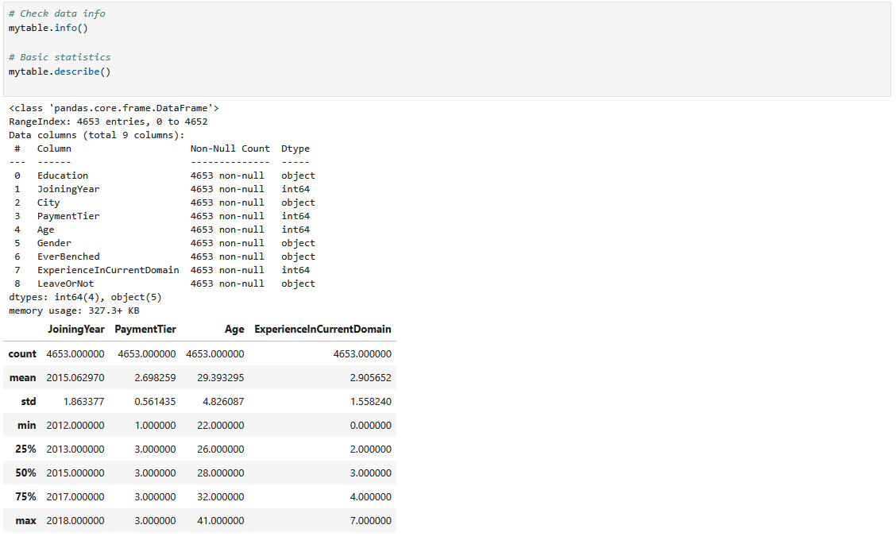

Data Cleaning
Checking for missing data:
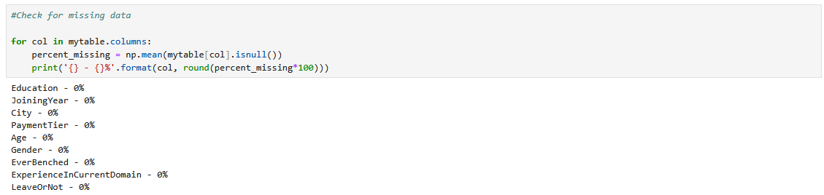
Removing Null values (if they exist):
Dropping duplicates:
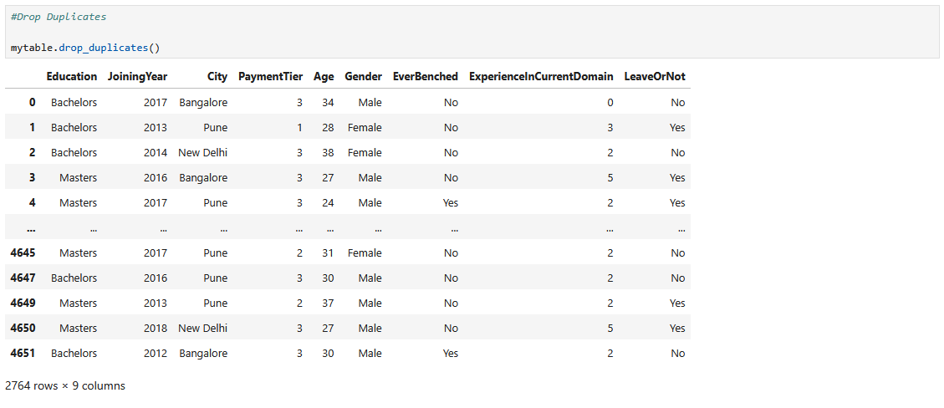

Making sure Gender and City have consistent formatting:
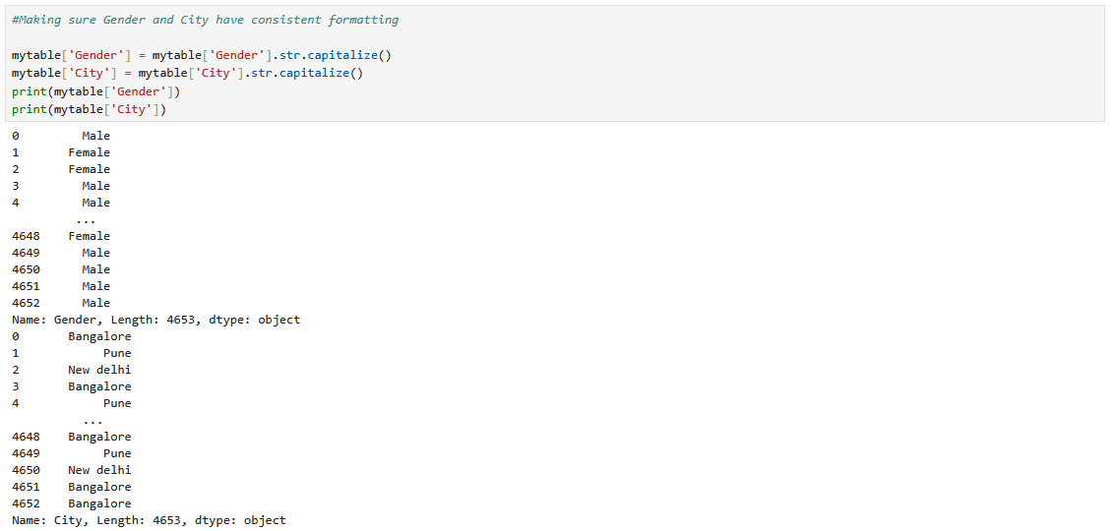

Data Analysis
Analyse age and gender distribution:
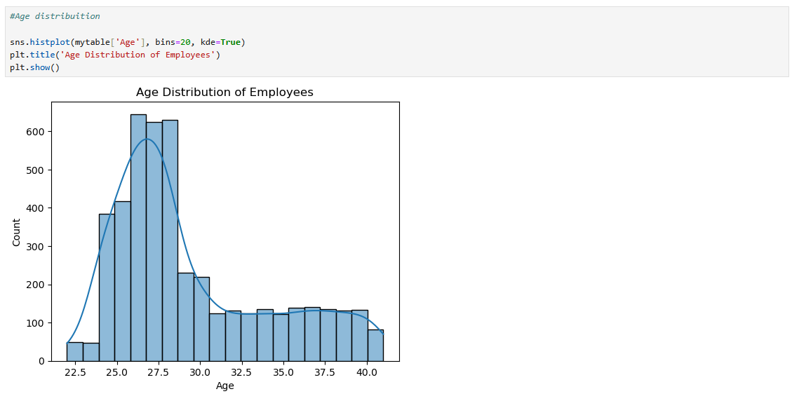
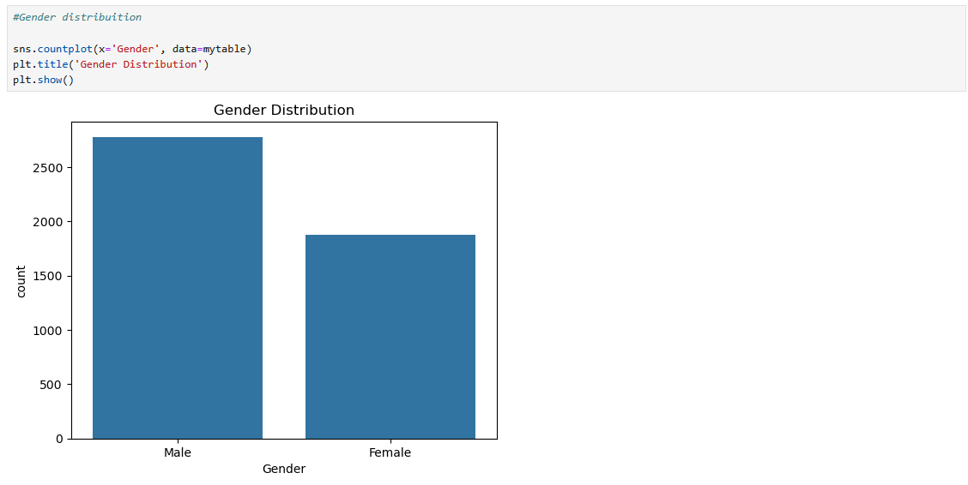
Count Employees per City
/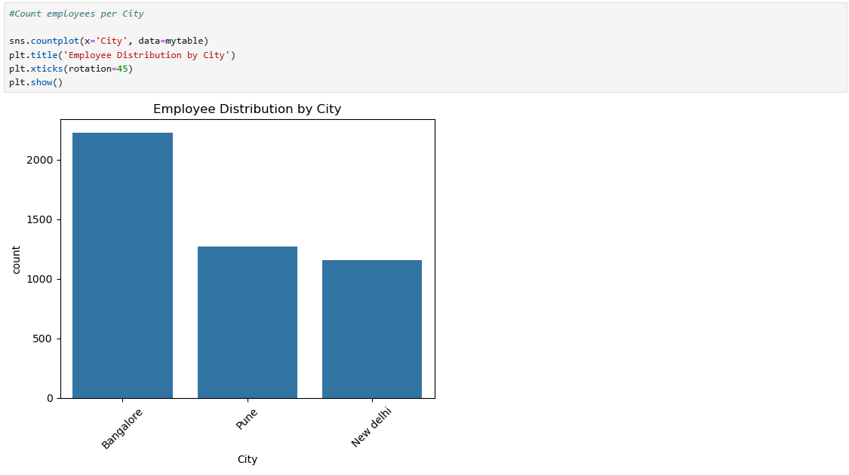
Average payment tier per education level (Float and Int):
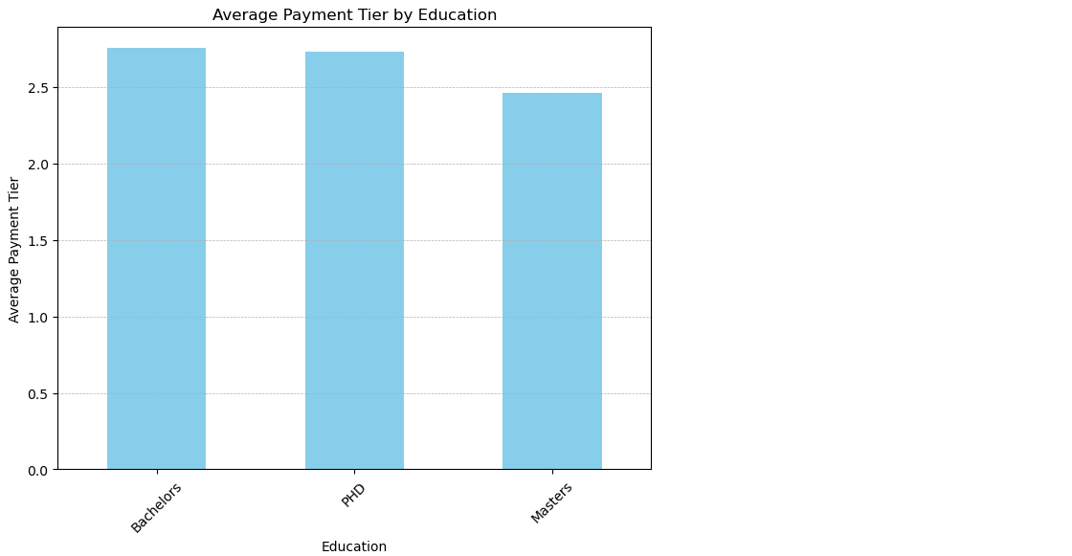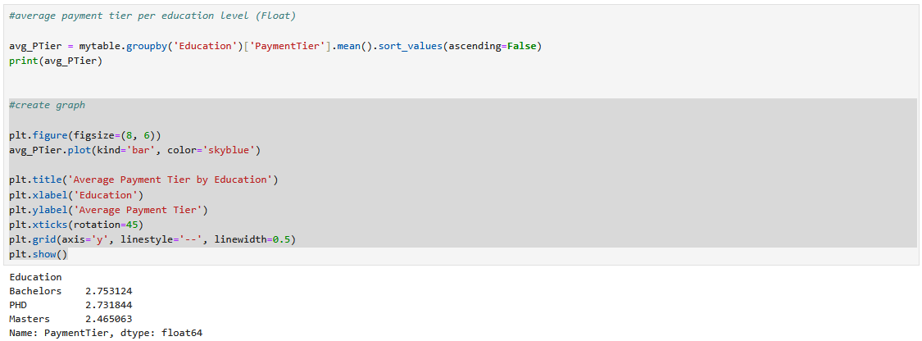
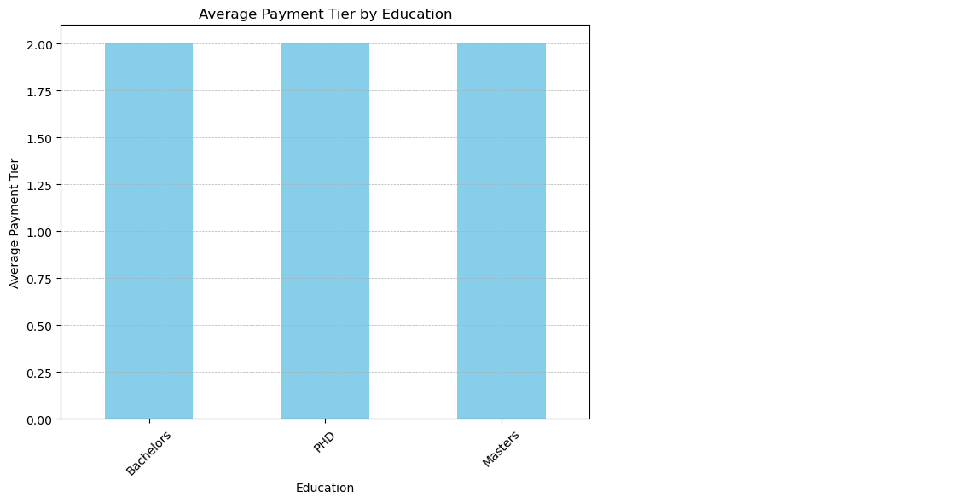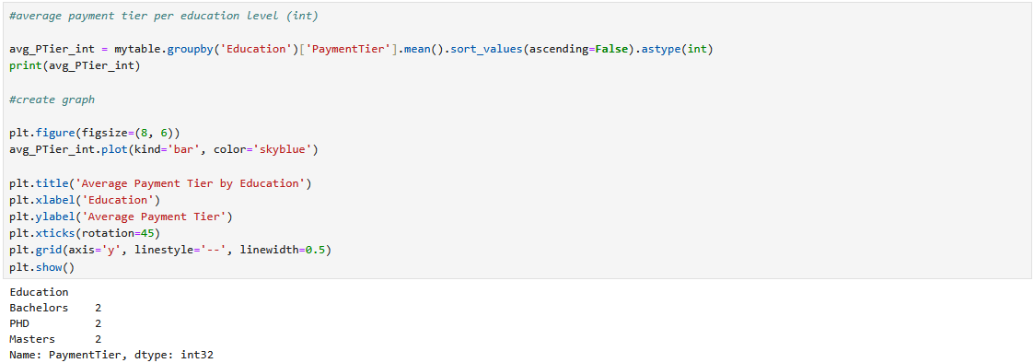
Relationship between payment tier and experience in current domain:
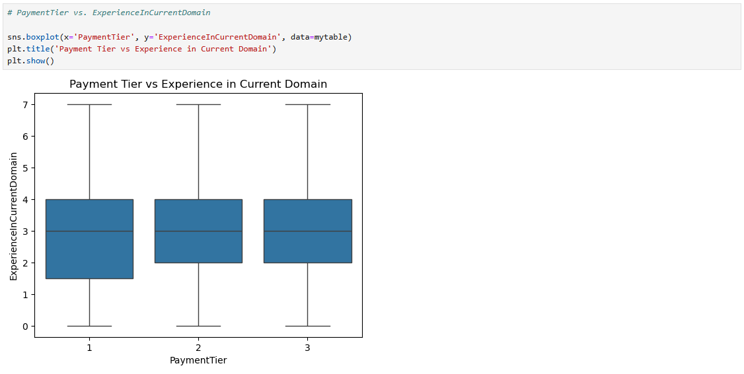
Check if experience in current domain influences whether employees take leave
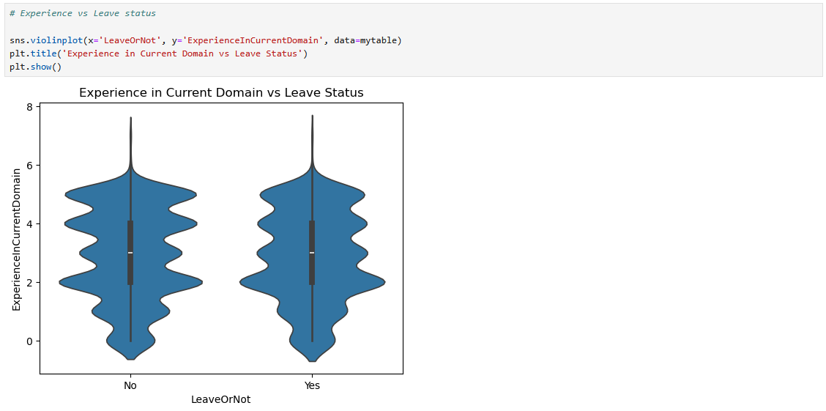
Check if the city influences whether employees take leave
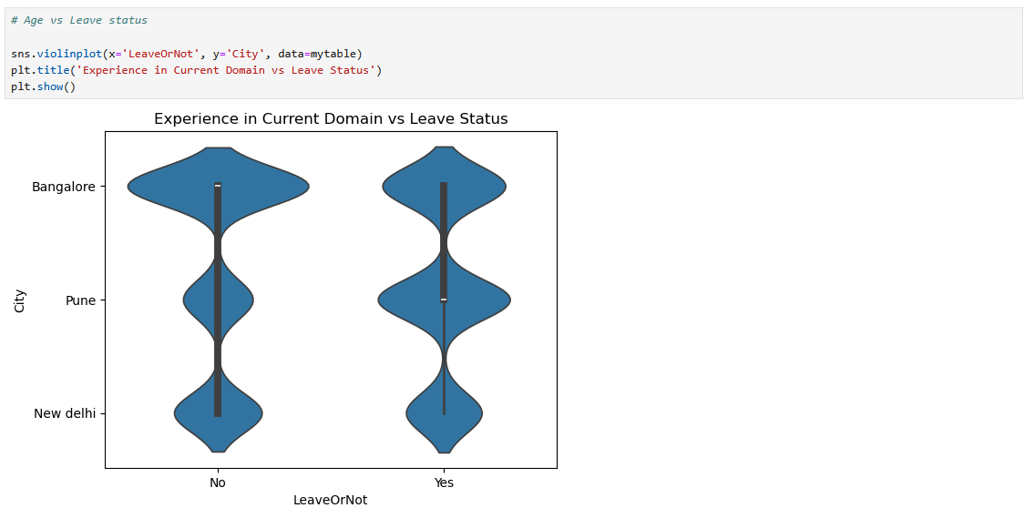

Key Insights
- The majority of employees are male and are roughly 25 to 30 years old
- There are more Employees from Bangalore than from any other city
- Employees with higher experience in current domain are paid more, although it seems employees with Masters Degree’s are paid less
- Employees with less experience in current domain are more likely to take leave
- Employees from Pune are more likely to take leave

